

IST 722 Data Warehouse Project –

Group 6

*Shreyas Kashyap Adarsh Jha Aditya Pawar*

*Prathmesh Pawar Karan Salunkhe*

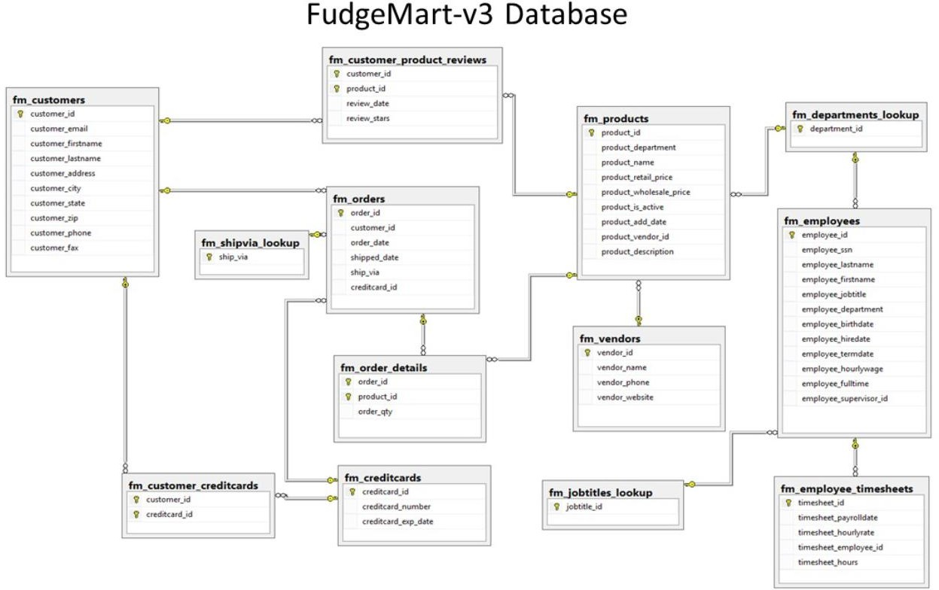Database

*FudgeMart – 20-year-old company*

# Business Process 1 –

Transaction / Event

* *Business Process*
  + Sales order and

details to understand business grain

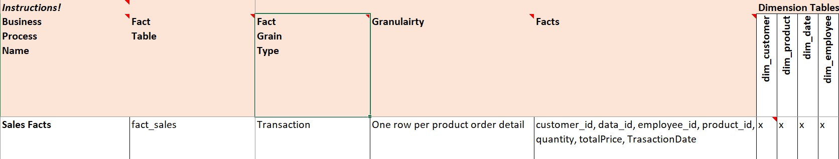



Sales Analytics

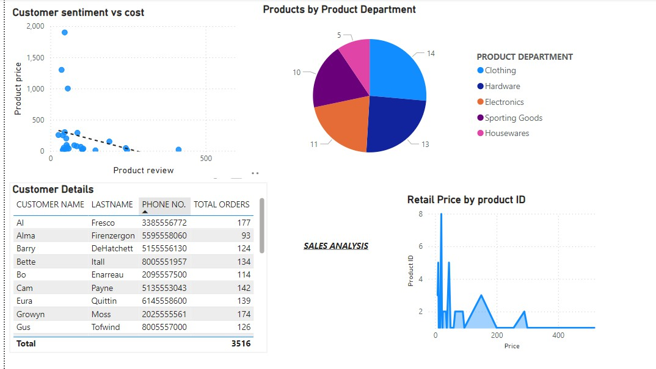

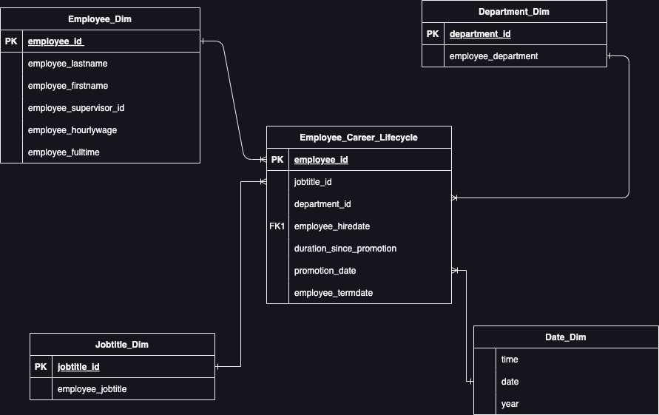Business Process 2 – Accumulating Snapshot

* *Business Process:*
  + People Analytics at Fudgemart

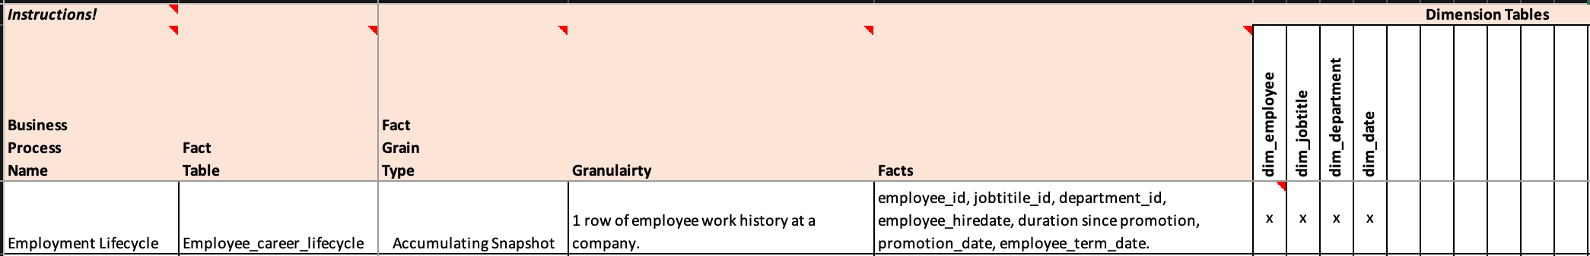

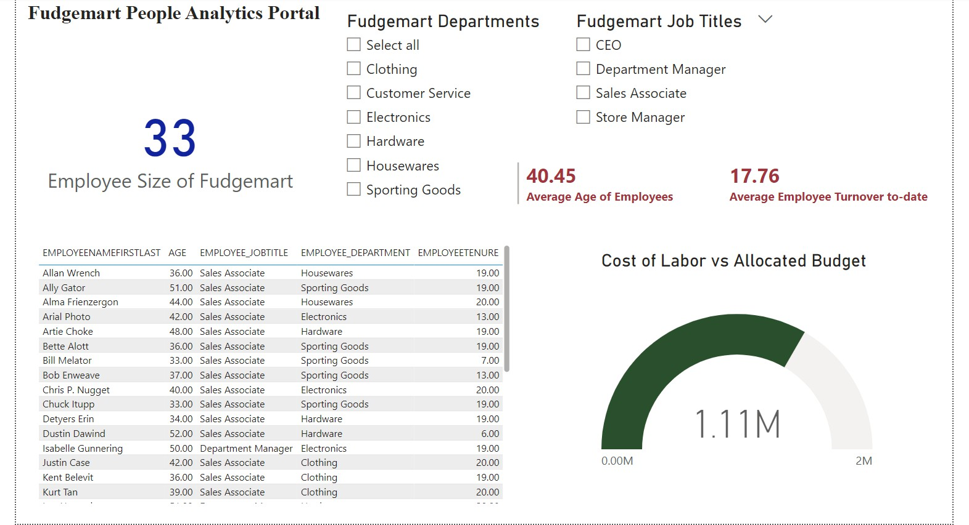

People Analytics at Fudgemart

Link to GitHub: [People Analytics ETL](https://github.com/sskashya/ist722dbt/tree/main/fudgemart/models)

Link to BI Dashboard: [People Analytics Dashboard](https://app.powerbi.com/links/N8Rwp-LCaz?ctid=4278a402-1a9e-4eb9-8414-ffb55a5fcf1e&pbi_source=linkShare)

# A screenshot of a computer Description automatically generatedA close-up of a pink background Description automatically generatedBusiness Process 3 : Periodic Snapshot

* *Business Process:*
* Customer Reviews



Product Popularity

